**User Manual**

The project can be downloaded from the URL:

<https://github.com/FreddyClaros/search-content/tree/master>

The project can be downloaded in format .zip

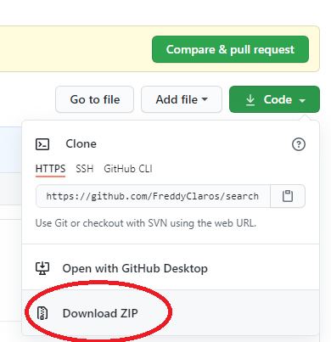

Once downloaded must be decompressed, and once inside the decompressed folder double click the “index.html” file

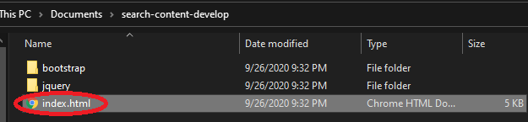

In case the question "How do you what to open this file" show up must selected some internet browser (Google Chrome for example), the project it will be opened as it's shown in the following

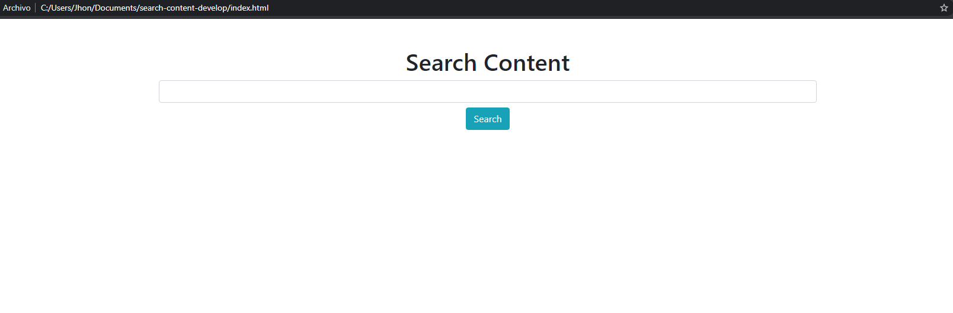

Search filed (write here what you want to search)

Search Button (clicked to begin the search)

The camps are simple, a field to tap the text to search and a button to search

Once the field was tipped and the bottom clicked it’ll be showed the results of the search as it's shown in the following

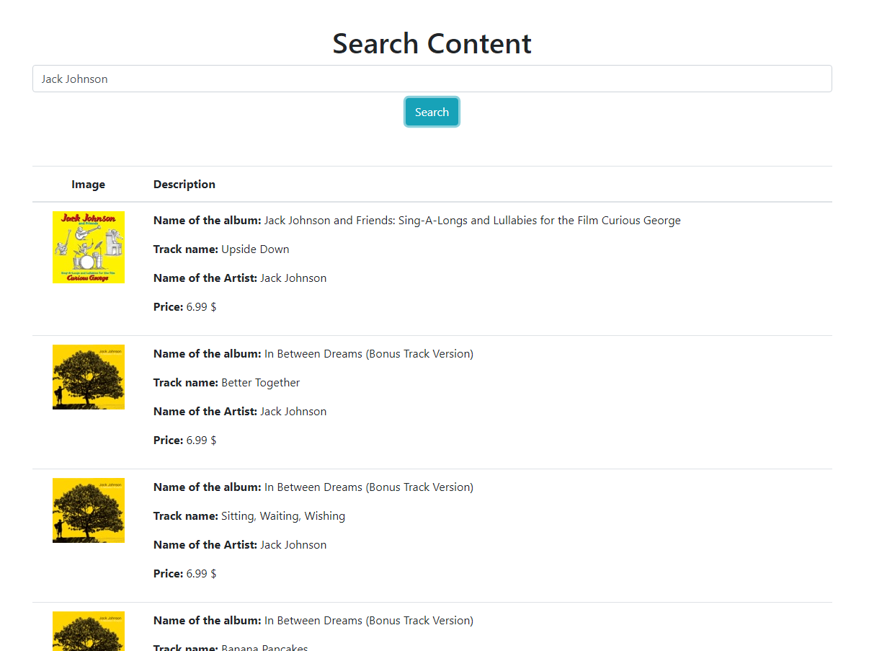

Results of the search